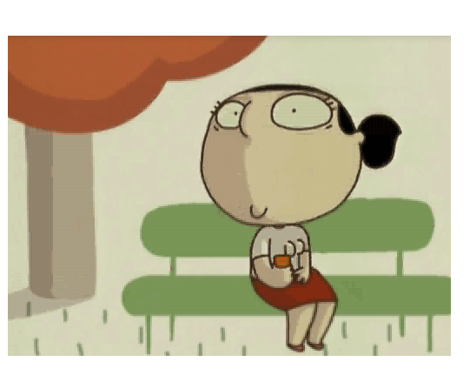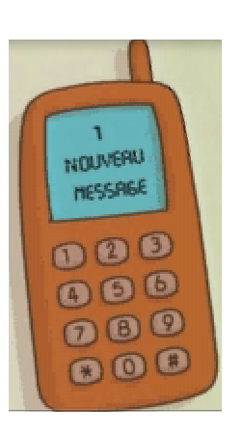

UN COURT-MÉTRAGE D’AURÉLIE CHARBONNIER

**LE BON NUMÉRO**

1. **C’est quoi l’histoire? What is the film about**?

From the title only, what do you think this short film is about?

From the picture, circle the correct type of film it is.

Do you know what they all mean in French? Try to translate!

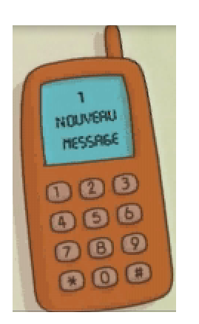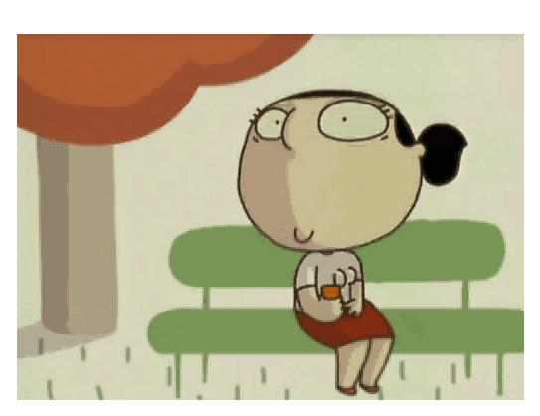

a) un film d’horreur b) un film d’action c) un film d’aventure

d) un dessin-animé/un film d’animation e) un film romantique

1. **Décris la mise-en-scène – describe the setting.**

|  |  |
| --- | --- |
| Le lieu – the place | Les personnages – the characters |
| L’histoire - the plot |

C:\Documents and Settings\mhuet.LAMPTON.007\Local Settings\Temporary Internet Files\Content.IE5\HV21EMHP\MC900290930[1].wmf

Look at some examples in French – which one is suitable for this film?

**Lieu** = supermarché – parc – cinéma – collège – gare – stade

**Les personnages** = un chat - une fille – un garçon – un monstre

**L’histoire** = un dîner au restaurant – un match de foot – un rendez-vous dans un parc – elle reçoit un message sur son portable…

**CHALLENGE : Décris le caractère principal :**

*You must include the following information: hair / eyes / gender / size / clothes (elle porte... = she wears...), etc...*

*C:\Documents and Settings\mhuet.LAMPTON.007\Local Settings\Temporary Internet Files\Content.IE5\HV21EMHP\MC900290930[1].wmf*

EXTENSION= describe the scene

(it takes place – *cela se passe*.../ I see – *je vois*...)

C:\Users\Muriel\AppData\Local\Microsoft\Windows\Temporary Internet Files\Content.IE5\Y03K2HT1\MCj04418800000[1].wmf

**Aide vocabulaire:**

Elle a / elle est ...

Les cheveux / les yeux

*For more vocab’, see* ***help sheet*** *at end of booklet.*

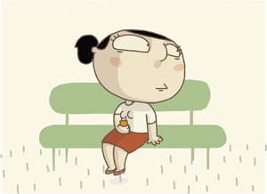

1. **Les autres caractères / the other characters:** what name will you give to the other characters / how will you describe them.

**Here are some ideas:**

|  |  |
| --- | --- |
| Le gourmand | The greedy |
| Le mangeur d’oiseau | The birds’ eater |
| Le vicieux | The vicious man (depraved) |
| Le dégoûtant | The disgusting |
| Le romantique | The romantic |
| Le gentil garçon | The nice boy |
| Le drageur | The flirty |
| Le macho | The macho |

2. *Nom (name) =*

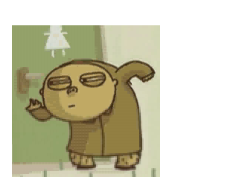

1. *Nom (name) =*

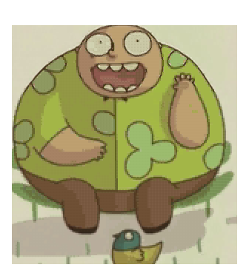

4. *Nom (name) =*

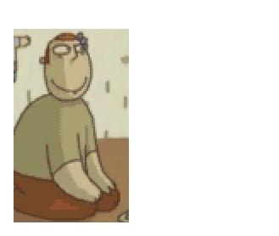

3. *Nom (name) =*

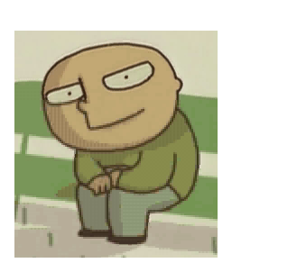

**FRENCH CHALLENGE:** Can you describe your favourite character (physical description and personality). And give your opinion on the character!

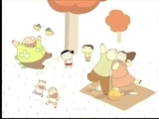

**SUGGESTION DE VOCABULAIRE:**

* He looks like = il a l’air de / il ressemble à
* I think that = je pense que
* In my opinion = à mon avis
* I find that = je trouve que

1. C:\Users\Muriel\AppData\Local\Microsoft\Windows\Temporary Internet Files\Content.IE5\YLQTQ9C9\MCj02371580000[1].wmf**Travaille avec ton partenaire : raconte la suite de l’histoire.** (In pairs, imagine how the story keeps going...)

C’est l’histoire d’une jeune fille qui recherche l’âme sœur. Elle reçoit un message qui lui explique son horoscope. Aujourd’hui, elle doit rencontrer le partenaire de ses rêves. La scène se passe dans un parc…

*It is the story of a young girl who looks for her soul mate. She receives a message telling her the horoscope. Today, she is going to meet the partner of her dreams. The scene takes place in a park...*

Look in both texts and find the French for:

the story =

a young girl =

today =

to meet =

the partner of her dreams =

takes places =

**En anglais :**

**C:\Users\Muriel\AppData\Local\Microsoft\Windows\Temporary Internet Files\Content.IE5\KBXSJ2G8\MC900098039[1].wmfCan you try to write few sentences in French using the future tense?**

A remind of the near future tense:

**+ +**

INFINITIVE VERB

PART OF ALLER

SUBJECT

manger

aller

jouer

travailler

etc...

Je

Tu

Il/elle/on

Nous

Vous

Ils / elles

vais

vas

va

allons

allez

vont

**C:\Users\Muriel\AppData\Local\Microsoft\Windows\Temporary Internet Files\Content.IE5\Y03K2HT1\MCj04418800000[1].wmf**

Se marier = to marry

Rencontrer = to meet

Choisir = to choose

Draguer = to flirt

Sortir avec = to go out with

avoir des enfants = to have children

être célibataire = to be single

aller au restaurant = to go to restaurant

*EXAMPLE*: I’m going to eat = je vais manger

***Now it’s your turn! Look at the possible verbs you***

***can use, and make up sentences?***

Elle va rencontrer le partenaire de ses rêves…

(she is going to meet her dreams’ partner…)

**C:\Documents and Settings\mhuet.LAMPTON\Local Settings\Temporary Internet Files\Content.IE5\0VXYH8YQ\MC900434411[1].wmfBON TRAVAIL!**

YOU FINISHED ALL ACTIVITIES ON

‘LE BON NUMÉRO’.

**NOW STATE 2 THINGS YOU HAVE LEARNT:**

(French words, anything on the film, etc…)

